Please try the questions by yourself and then you can verify the answers from the solutions file.

You are required to run the InitialScript.sql first to create a table and insert the data into the table.

Please write the following command after executing the InitialScript.sql using Dbase Database.
select * from Employees

You will get the following output as shown in the screenshot

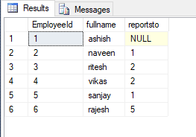

You are required to write T-SQL code to generate the following output as shown in the screenshot given below.

You need to display the Employee Full Name and its corresponding Manager name along with the Employee’s Hierarchy Level in the organization

